IEEE Transactions on Industry Applications

Dear Dr. Nondahl,

Kindly find attached paper entitled “Towards a New Paradigm for Ultrafast Transmission Line Relaying” which I am submitting for exclusive consideration for IEEE Transactions on Industry Applications.

Distance protection of transmission lines suffers from known shortcomings which are more noticeable with the advent of wind energy. The paper proposes an algorithm that can be used for providing fault protection for the transmission line under study and its adjacent lines using local currents only from any end. The paper can also classify transients on the line protected and its adjacent lines identifying the line causing the transient event type in a very accurate manner. Further research is being conducted to apply the approach to distribution lines as well as validation the proposed approach using field data.

Given the breadth and the depth of the EMTP simulations carried out in this paper, I think that the paper is a valuable addition to literature which I hope you agree to and consider it for review in IEEE Transactions on Industry Applications.

For ease of review and validation of results, all data sets used in this paper are available upon request.

The following international authorities in the field are among those who might agree to review the transcript: Carl Benner and [Dr. Krish Narendra](mailto:knarendra@erlphase.com).

Po-Chen Chen of Texas A&M University has helped review and proof-read the manuscript and it will not add to the paper if he is assigned as reviewer for it.

Finally, I hope you and the reviewers find the paper enjoyable as I found it during preparation, simulation, writing and proof reading.

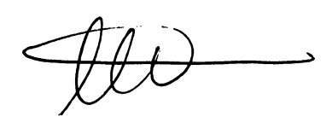

Ahmad Abdullah

Power System Design Engineer

Electric Power Engineers Inc.,

Austin, TX, 78738